Ahmad Barakat | ITEC 422 | Wireshark Lab 3

1. What is the IP address and TCP port number used by the client computer (source)
that is transferring the file to gaia.cs.umass.edu?

The source is 192.168.1.102, Port: 1161

2. What is the IP address of gaia.cs.umass.edu? On what port number is it sending
and receiving TCP segments for this connection?

192.168.86.197 with port number 1514

3. What is the IP address and TCP port number used by your client computer
(source) to transfer the file to gaia.cs.umass.edu?

435 3.467579 128.119.245.12 192.168.86.197 TCP 66 80 → 53712 [SYN, ACK] Seq=0 Ack=1 Win=29200 Len=0 MSS=1460 SACK_PERM WS=128(copied summary as text)
128.199,.245.12, port number 66

4. What is the sequence number of the TCP SYN segment that is used to initiate the
TCP connection between the client computer and gaia.cs.umass.edu? What is it
in the segment that identifies the segment as a SYN segment?
Sequence: 0, on the TCP segment it says [SYN].

5. What is the sequence number of the SYNACK segment sent by gaia.cs.umass.edu
to the client computer in reply to the SYN? What is the value of the
Acknowledgement field in the SYNACK segment? How did gaia.cs.umass.edu
determine that value? What is it in the segment that identifies the segment as a SYNACK segment?
Sequence: 0, Ack: 1, one greater than client sequence number. also 1.

6. What is the sequence number of the TCP segment containing the HTTP POST command?
Sequence: 1

7. Consider the TCP segment containing the HTTP POST as the first segment in the
TCP connection. What are the sequence numbers of the first six segments in the
TCP connection (including the segment containing the HTTP POST)? At what
time was each segment sent? When was the ACK for each segment received?
Given the difference between when each TCP segment was sent, and when its
acknowledgement was received, what is the RTT value for each of the six
segments? What is the EstimatedRTT value (see page 237 in text) after the
receipt of each ACK?
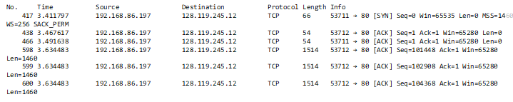
Sequence numbers of first 6 segments: 1, 0, 1, 101448, 102908, 104368
Ack received - sent time = RTT
Seg 1: 0.0798 Sec
Seg 2: 0.064 Sec
Seg 3: 0.142 Sec
Seg 4: 46.5 ms
Seg 5: 46.5 ms
Seg 6: 46.5 ms

8. What is the length of each of the first six TCP segments?
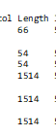
9. What is the minimum amount of available buffer space advertised at the received
for the entire trace? Does the lack of receiver buffer space ever throttle the
sender?
At some point within the trace, the Win is 297, the lack of the receiver buffer space will stop the sender at 0 because there is no space for more data.

10. Are there any retransmitted segments in the trace file? What did you check for (in
the trace) in order to answer this question?
I don’t notice any retransmitting, I check if there is any similarity within the actual data.

11. How much data does the receiver typically acknowledge in an ACK? Can you
identify cases where the receiver is ACKing every other received segment (see
Table 3.2 on page 247 in the text).
The receiver acknowledges the byte in an ACK. The receiver will ACK every other segment when there is
Packet loss.

12.What is the throughput (bytes transferred per unit time) for the TCP connection?
Explain how you calculated this value
6801 bytes/unit time.
By dividing the bytes (1514) by the time of the TCP connection time (0.222595 sec).

13. Use the Time-Sequence-Graph(Stevens) plotting tool to view the sequence number versus time
plot of segments being sent from the client to thegaia.cs.umass.edu server. Can you identify
where TCP’s slow start phase begins and ends, and where congestion avoidance takes over?

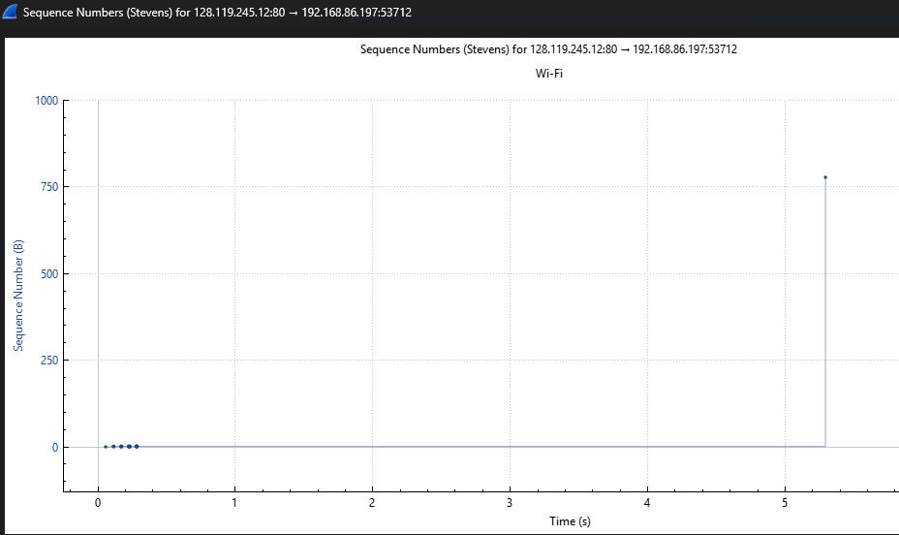
The slow start phase begins at sequence number 0, then 5.3 seconds the congestion avoidance takes over.

14. Answer each of two questions above for the trace that you have gathered when you
transferred a file from your computer to gaia.cs.umass.edu
